The pdf and ppt reports download ok.
TIMELINE
In ppt (not ok)
Only the content of the Gantt is shown, milestone and phases, the legend and the timeline and column titles are not seen.
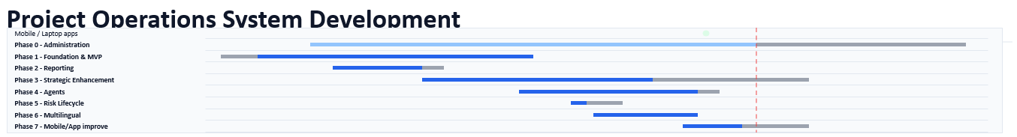
In pdf (not OK)
The top of the Gantt is perfect but the other sections still land above part of the Gantt.
Screen
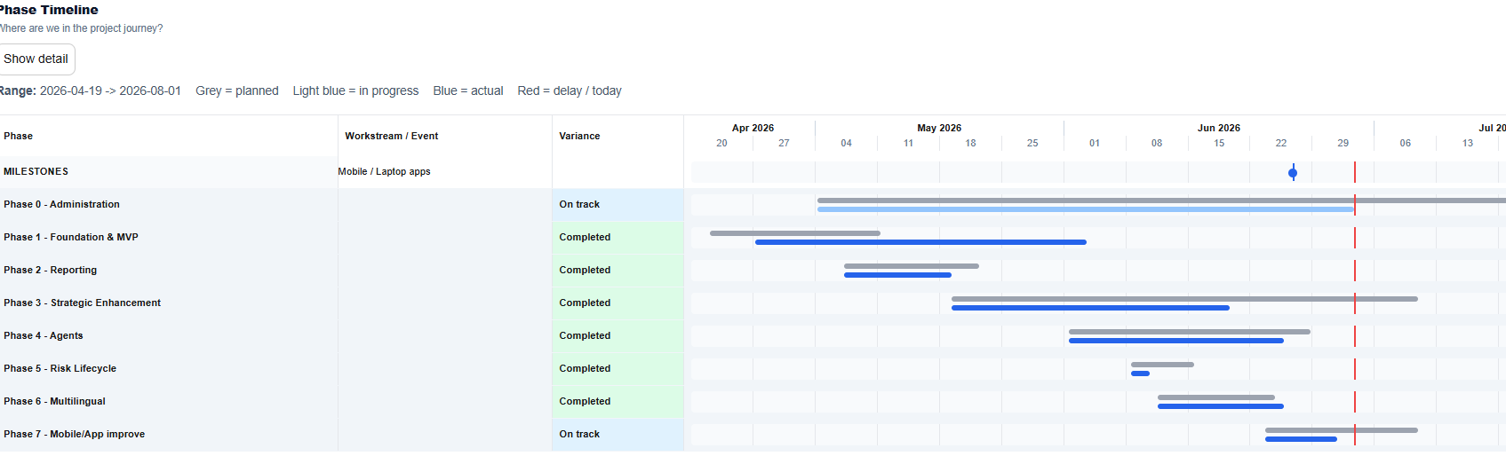

The sections with Cockpit are not like on the screen:

In ppt they are non existent. Only for delivery status appear some numbers.
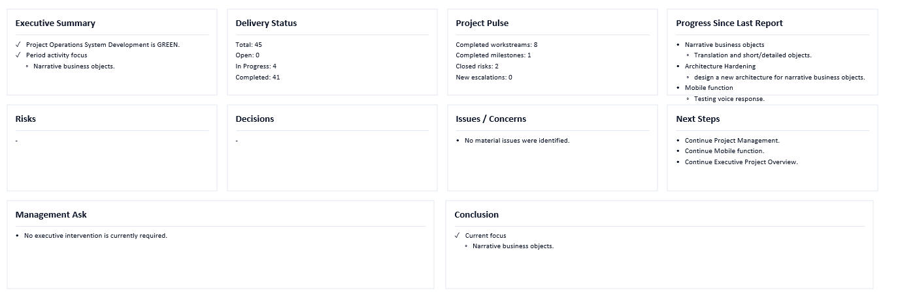

In pdf we have the same problem but in Delivery status something is visible

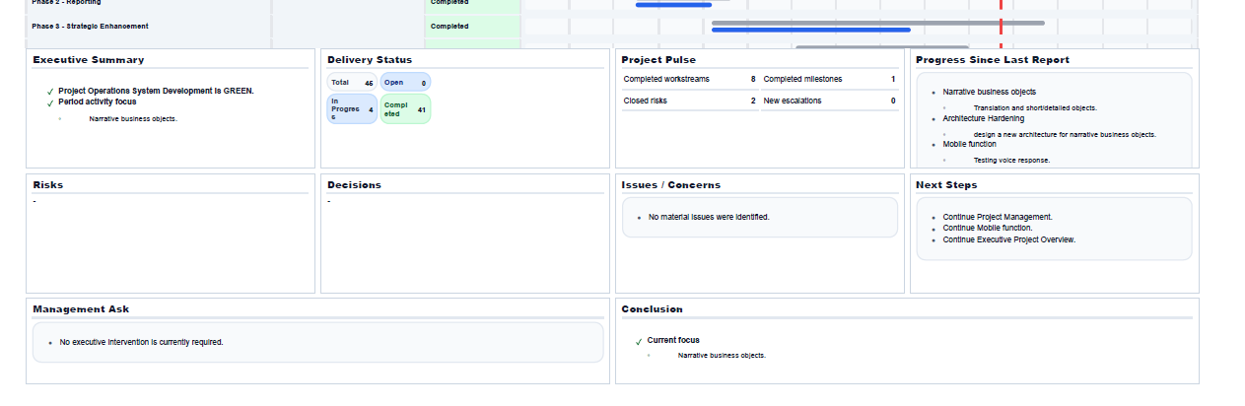

This tells me that the briefing is not using the same source of truth than the screen for all the graphics.

